1. 
2. We will learn how to write RESTful Web Service App using JAX-RS technology.
3. We need to learn two things when writing RESTful APIs or RESTful Services using JAX-RS.
   1. About RESTful API itself.
   2. How to implement them using JAX-RS.
4. This section is divided into two parts.
   1. First Part contains.
      1. Introduction to RESTful Web Service. Concepts and Best Practices.
   2. Second Part about implementation with JAX-RS.
5. Let’s start with “**Web Service**”.
6. What is Web Service?
   1. Services that are exposed over internet for programmatic access.
   2. It is online API which you can call from your code.
   3. 
   4. 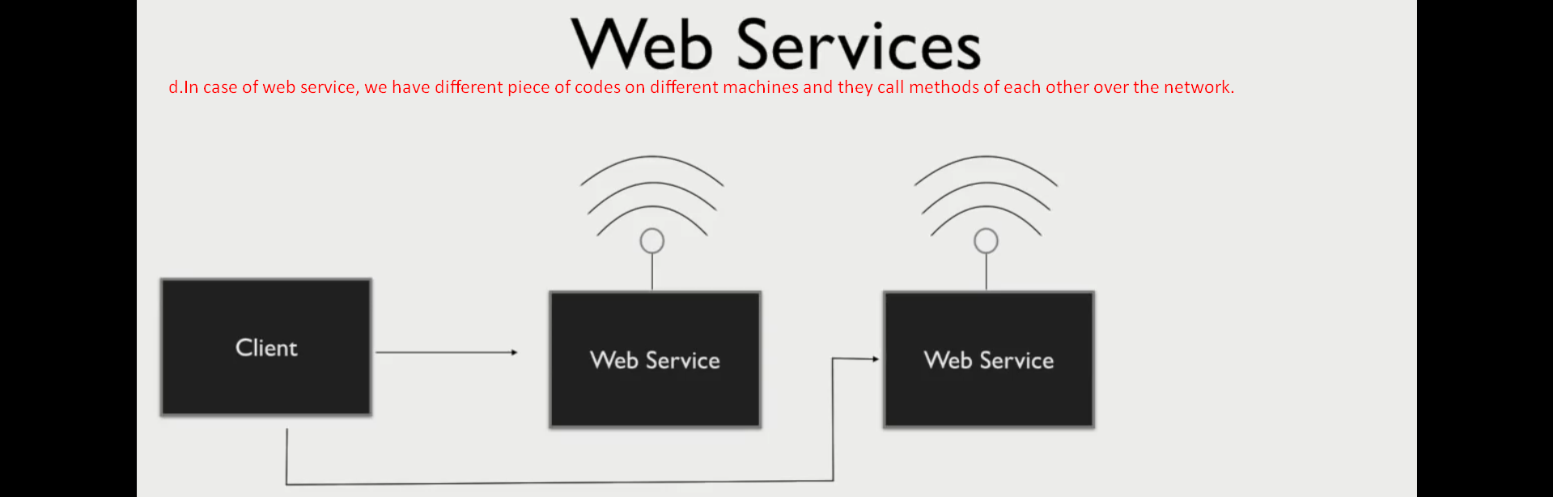
   5. 
   6. 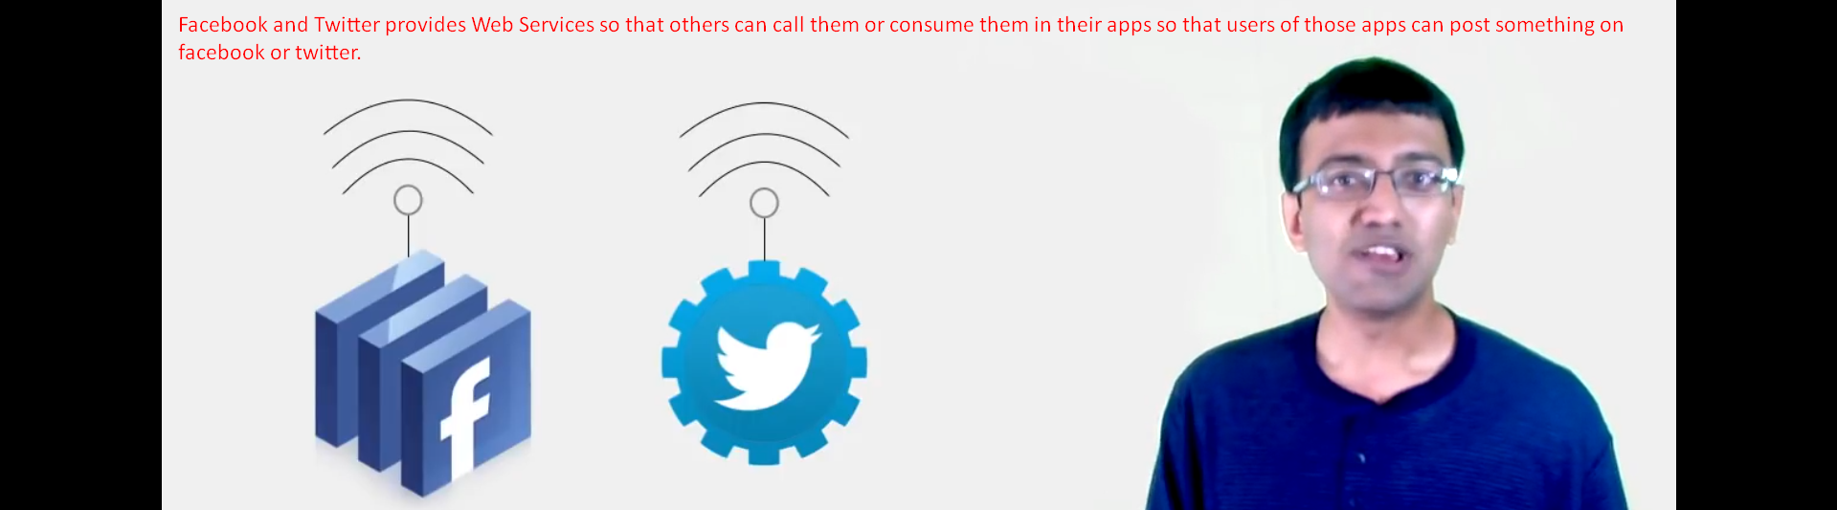
   7. 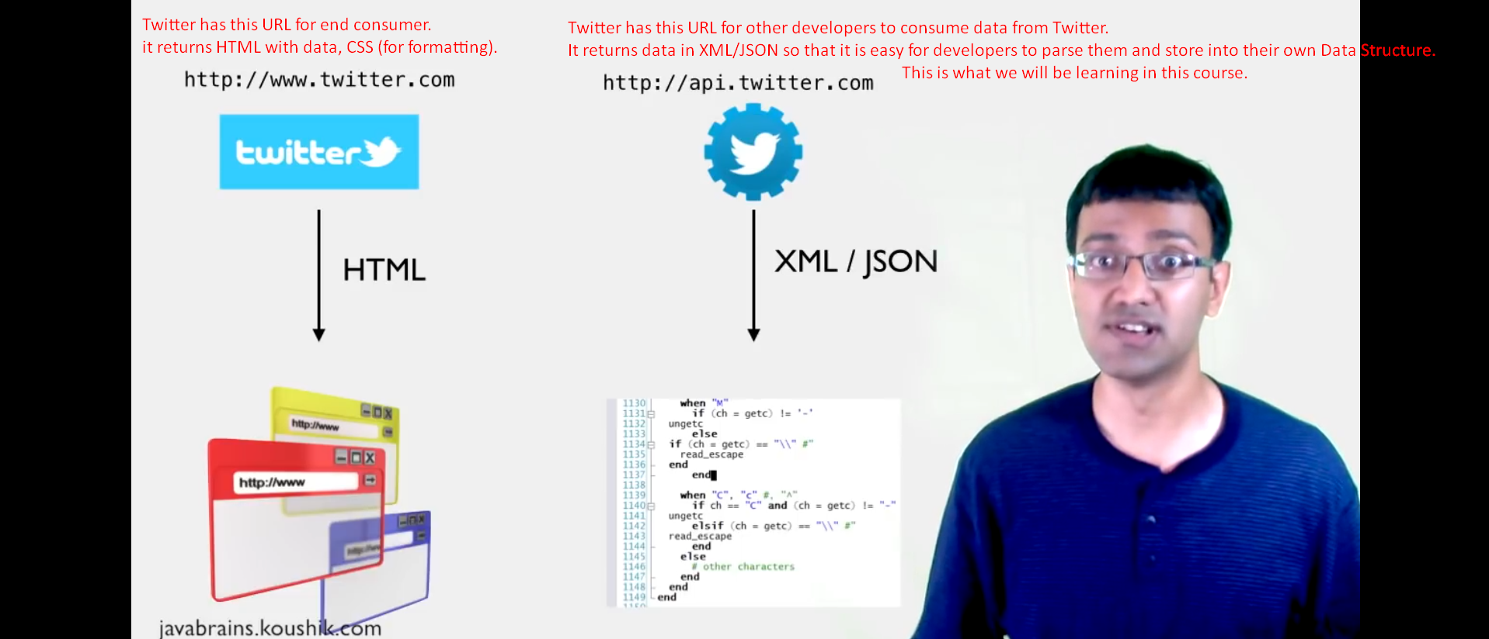Bare-Bone data
7. RESTful Web Services/APIs are types of web services which are modern, lightweight which uses technology behind HTTP (HTTP derives the Web).
8. 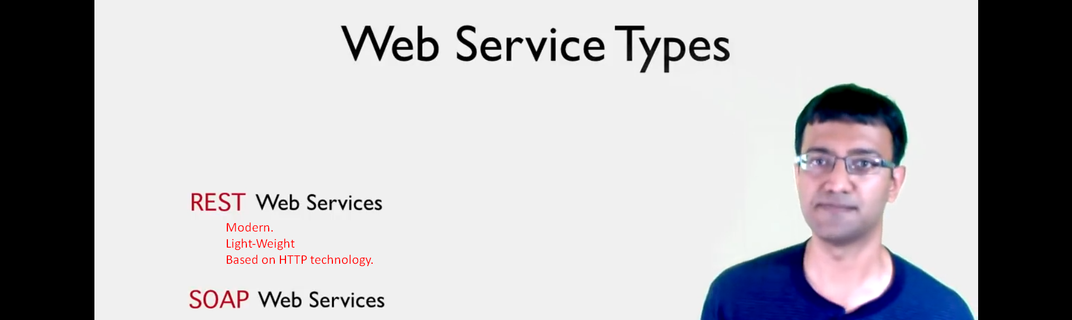
9. 